ASSIGNMENT 4

Name : Nivetha A

import pandas as pd import numpy as np

import seaborn as sns

import matplotlib.pyplot as plt

from google.colab import files upload=files.upload()

df=pd.read_csv('abalone.csv') df.describe()

abalone.csv

Choose files

**abalone.csv**(text/csv) - 191962 bytes, last modiﬁed: 31/10/2022 - 100% done

Saving abalone.csv to abalone (1).csv

**Length Diameter Height Whole**

|  |  |  |  |  |  |  |  |
| --- | --- | --- | --- | --- | --- | --- | --- |
|  | | | | **weight** | **weight** | **weight** |  |
| **count** | 4177.000000 | 4177.000000 | 4177.000000 | 4177.000000 | 4177.000000 | 4177.000000 | 4177 |
| **mean** | 0.523992 | 0.407881 | 0.139516 | 0.828742 | 0.359367 | 0.180594 | 0 |
| **std** | 0.120093 | 0.099240 | 0.041827 | 0.490389 | 0.221963 | 0.109614 | 0 |
| **min** | 0.075000 | 0.055000 | 0.000000 | 0.002000 | 0.001000 | 0.000500 | 0 |
| **25%** | 0.450000 | 0.350000 | 0.115000 | 0.441500 | 0.186000 | 0.093500 | 0 |
| **50%** | 0.545000 | 0.425000 | 0.140000 | 0.799500 | 0.336000 | 0.171000 | 0 |
| **75%** | 0.615000 | 0.480000 | 0.165000 | 1.153000 | 0.502000 | 0.253000 | 0 |
|  |  |  |  |  |  |  |  |

**Shucked**

**Viscera**

df.head()

**Sex Length Diameter Height Whole**

|  |  |  |  |  |  |  |  |
| --- | --- | --- | --- | --- | --- | --- | --- |
|  | | | **weight** | **weight** | **weight** | **weight** |  |
| **0** | M 0.455 | 0.365 | 0.095 0.5140 | 0.2245 | 0.1010 | 0.150 | 15 |
| **1** | M 0.350 | 0.265 | 0.090 0.2255 | 0.0995 | 0.0485 | 0.070 | 7 |
| **2** | F 0.530 | 0.420 | 0.135 0.6770 | 0.2565 | 0.1415 | 0.210 | 9 |
| **3** | M 0.440 | 0.365 | 0.125 0.5160 | 0.2155 | 0.1140 | 0.155 | 10 |
| **4** | I 0.330 | 0.255 | 0.080 0.2050 | 0.0895 | 0.0395 | 0.055 | 7 |

**Shucked**

**Viscera**

**Shell**

**Rings**

sns.boxplot(df.Length)

/usr/local/lib/python3.7/dist-packages/seaborn/_decorators.py:43: FutureWarning: Pass t FutureWarning

<matplotlib.axes._subplots.AxesSubplot at 0x7fc169f7ca50>

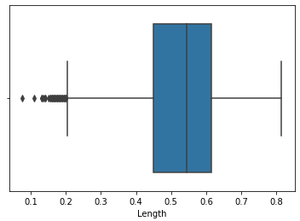

sns.countplot(x='Sex',data=df,palette='Set3')

<matplotlib.axes._subplots.AxesSubplot at 0x7fc169a05750>

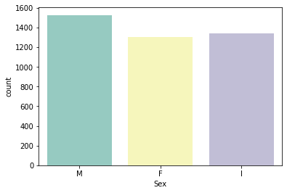

a=pd.read_csv('abalone.csv')

a['age']=a['Rings']+1.5 a=a.drop('Rings',axis=1)

sns.kdeplot(a['Diameter'])

<matplotlib.axes._subplots.AxesSubplot at 0x7fc169986a90>

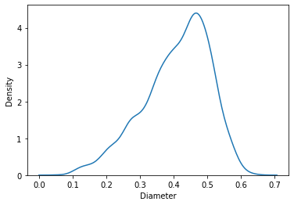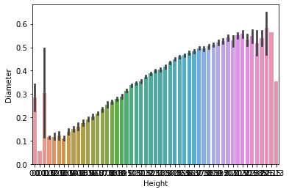

sns.barplot(x=df.Height,y=df.Diameter)

<matplotlib.axes._subplots.AxesSubplot at 0x7fc169928fd0>

sns.pairplot(a)

<seaborn.axisgrid.PairGrid at 0x7fc1696dbc90>

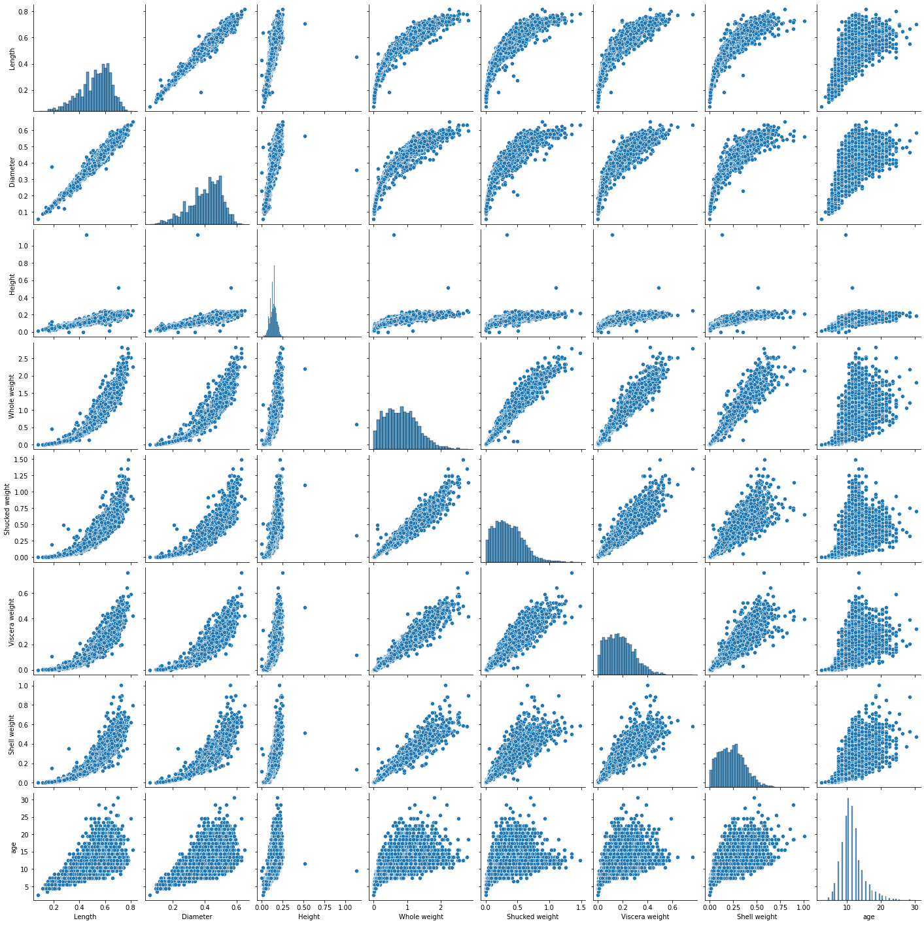

a.info()

<class 'pandas.core.frame.DataFrame'> RangeIndex: 4177 entries, 0 to 4176

Data columns (total 9 columns):

# Column Non-Null Count Dtype

1. Sex 4177 non-null object
2. Length 4177 non-null float64
3. Diameter 4177 non-null float64
4. Height 4177 non-null float64
5. Whole weight 4177 non-null float64
6. Shucked weight 4177 non-null float64
7. Viscera weight 4177 non-null float64
8. Shell weight 4177 non-null float64
9. age 4177 non-null float64 dtypes: float64(8), object(1)

memory usage: 293.8+ KB

a['Diameter'].describe()

|  |  |
| --- | --- |
| count | 4177.000000 |
| mean | 0.407881 |
| std | 0.099240 |
| min | 0.055000 |
| 25% | 0.350000 |
| 50% | 0.425000 |
| 75% | 0.480000 |
| max | 0.650000 |
| Name: | Diameter, dtype: float64 |

a['Sex'].value_counts()

|  |  |
| --- | --- |
| M | 1528 |
| I | 1342 |
| F | 1307 |

Name: Sex, dtype: int64

df['Height'].describe()

|  |  |
| --- | --- |
| count | 4177.000000 |
| mean | 0.139516 |
| std | 0.041827 |
| min | 0.000000 |
| 25% | 0.115000 |
| 50% | 0.140000 |
| 75% | 0.165000 |

max 1.130000

Name: Height, dtype: float64 df[df.Height==0]

**Sex Length Diameter Height Whole**

**weight**

**Shucked weight**

**Viscera weight**

**Shell weight**

**Rings**

**1257** I 0.430 0.34 0.0 0.428 0.2065 0.0860 0.1150 8

**3996** I 0.315 0.23 0.0 0.134 0.0575 0.0285 0.3505 6

df['Diameter'].median() 0.425

df['Shucked weight'].skew() 0.7190979217612694

missing_values=df.isnull().sum().sort_values(ascending=False) percentage_missing_values=(missing_values/len(df))*100

pd.concat([missing_values,percentage_missing_values],axis=1,keys=['Missing values','%'])



|  |  |  |  |
| --- | --- | --- | --- |
|  | **Missing** | **values** | **%** |
| **Sex** |  | 0 | 0.0 |
| **Length** |  | 0 | 0.0 |
| **Diameter** |  | 0 | 0.0 |
| **Height** |  | 0 | 0.0 |
| **Whole weight** |  | 0 | 0.0 |
| **Shucked weight** |  | 0 | 0.0 |
| **Viscera weight** |  | 0 | 0.0 |
| **Shell weight** |  | 0 | 0.0 |
| **Rings** |  | 0 | 0.0 |

q1=df.Rings.quantile(0.25) q2=df.Rings.quantile(0.75) iqr=q1-q2

print(iqr)

-3.0

df=pd.get_dummies(df)

dummy_df=df

df.boxplot(rot=90 ,figsize=(20,5))

<matplotlib.axes._subplots.AxesSubplot at 0x7fc164f09310>

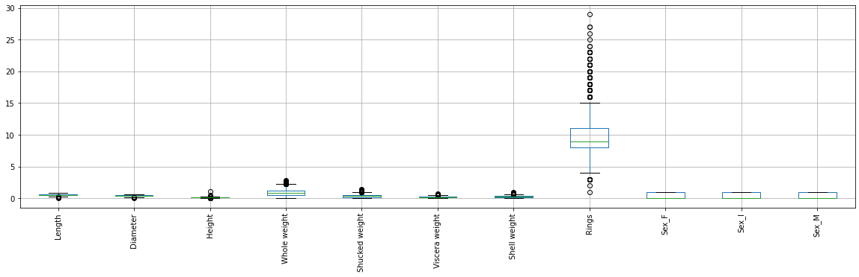

df['age']=df['Rings']

df=df.drop('Rings',axis=1)

df.drop(df[(df['Viscera weight']>0.5)& (df['age']<20)].index,inplace=True) df.drop(df[(df['Viscera weight']<0.5)& (df['age']>25)].index,inplace=True)

var='Shell weight'

plt.scatter(x=df[var],y=df['age'])

<matplotlib.collections.PathCollection at 0x7fc1634bf0d0>

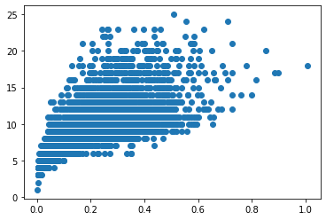

numerical_features=df.select_dtypes(include=[np.number]).columns categorical_features=df.select_dtypes(include=[np.object]).columns

/usr/local/lib/python3.7/dist-packages/ipykernel_launcher.py:2: DeprecationWarning: `np Deprecated in NumPy 1.20; for more details and guidance: [https://numpy.org/devdocs/rele](https://numpy.org/devdocs/release/1.20.0-notes.html#deprecations)

abalone_numeric=df[['Length','Diameter','Height','Whole weight','Shucked weight','Viscera wei

abalone_numeric.head()

**Length Diameter Height Whole**

|  |  |  |  |  |  |  |
| --- | --- | --- | --- | --- | --- | --- |
|  | | **weight** | **weight** | **weight** | **weight** |  |
| **0** 0.455 | 0.365 | 0.095 0.5140 | 0.2245 | 0.1010 | 0.150 | 15 |
| **1** 0.350 | 0.265 | 0.090 0.2255 | 0.0995 | 0.0485 | 0.070 | 7 |
| **2** 0.530 | 0.420 | 0.135 0.6770 | 0.2565 | 0.1415 | 0.210 | 9 |
| **3** 0.440 | 0.365 | 0.125 0.5160 | 0.2155 | 0.1140 | 0.155 | 10 |
| **4** 0.330 | 0.255 | 0.080 0.2050 | 0.0895 | 0.0395 | 0.055 | 7 |

**Shucked**

**Viscera**

**Shell**

**age**

x=df.iloc[:,0:1].values

y=df.iloc[:,1] y

|  |  |  |
| --- | --- | --- |
| 0 | 0.365 |  |
| 1 | 0.265 |  |
| 2 | 0.420 |  |
| 3 | 0.365 |  |
| 4  4172 | 0.255  ...  0.450 |  |
| 4173 | 0.440 |  |
| 4174 | 0.475 |  |
| 4175 | 0.485 |  |
| 4176  Name: | 0.555  Diameter, Length: 4150, | dtype: float64 |

print("\n ORIGNAL VALUES:\n\n", x,y )

ORIGNAL VALUES: [[0.455]

[0.35 ]

[0.53 ]

...

[0.6 ]

[0.625]

|  |  |  |
| --- | --- | --- |
| [0.71 | ]] 0 | 0.365 |
| 1 | 0.265 |  |
| 2 | 0.420 |  |
| 3 | 0.365 |  |
| 4 | 0.255 |  |
| 4172 | ...  0.450 |  |
| 4173 | 0.440 |  |
| 4174 | 0.475 |  |
| 4175 | 0.485 |  |
| 4176 | 0.555 |  |

Name: Diameter, Length: 4150, dtype: float64 from sklearn import preprocessing

min_max_scaler=preprocessing.MinMaxScaler(feature_range=(0,1)) new_y=min_max_scaler.fit_transform(x,y)

print("\n Values after min max scaling: \n\n", new_y)

Values after min max scaling:

[[0.51351351]

[0.37162162]

[0.61486486]

...

[0.70945946]

[0.74324324]

[0.85810811]]

x=df.drop('age',axis=1) y=df['age']

from sklearn.preprocessing import StandardScaler

from sklearn.model_selection import train_test_split,cross_val_score from sklearn.feature_selection import SelectKBest

StandardScale=StandardScaler() StandardScale.fit_transform(x)

|  |  |  |  |  |
| --- | --- | --- | --- | --- |
| array([[-0.56736455, | -0.42395732, -1.05992592, | | ..., | -0.67424712, |
| -0.69131775, | 1.32156176], | |  |  |
| [-1.44754363, | -1.43820927, -1.1801252 , | | ..., | -0.67424712, |
| -0.69131775, | 1.32156176], | |  |  |
| [ 0.0613348 , | 0.13388126, -0.0983317 , | | ..., | 1.48313573, |
| -0.69131775, | -0.75668049], | |  |  |
| ..., |  | |  |  |
| [ 0.64812085, | 0.69171983, | 1.58445819, | ..., | -0.67424712, |
| -0.69131775, | 1.32156176], |  |  |  |
| [ 0.8576873 , | 0.79314503, | 0.26226613, | ..., | 1.48313573, |
| -0.69131775, | -0.75668049], |  |  |  |
| [ 1.57021323, | 1.50312139, | 1.34405963, | ..., | -0.67424712, |
| -0.69131775, | 1.32156176]]) |  |  |  |

SelectkBest=SelectKBest()

x_new=SelectkBest.fit_transform(x,y)

x_train,x_test,y_train,y_test=train_test_split(x_new,y,test_size=0.25) x_train

array([[0.525,

|  |  |  |  |  |  |  |  |  |  |  |
| --- | --- | --- | --- | --- | --- | --- | --- | --- | --- | --- |
| 0.425, | | 0.12 | , | ..., | 0. | , | 0. | , | 1. | ], |
| 0.355, | | 0.14 | , | ..., | 0. | , | 1. | , | 0. | ], |
| 0.445, | | 0.13 | , | ..., | 1. | , | 0. | , | 0. | ], |
| 0.28 | , | 0.085, | | ..., | 0. | , | 1. | , | 0. | ], |

[0.46 ,

[0.59 ,

...,

[0.38 ,

|  |  |  |  |  |  |  |  |  |  |
| --- | --- | --- | --- | --- | --- | --- | --- | --- | --- |
| [0.645, | 0.49 | , | 0.19 , | ..., | 1. | , | 0. , | 0. | ], |
| [0.465, | 0.37 | , | 0.115, | ..., | 0. | , | 1. , | 0. | ]]) |

y_train

|  |  |  |
| --- | --- | --- |
| 734 | 18 |  |
| 583 | 13 |  |
| 766 | 13 |  |
| 1113 | 8 |  |
| 2857 | 11  .. |  |
| 1564 | 7 |  |
| 2886 | 8 |  |
| 2166 | 6 |  |
| 3918 | 18 |  |
| 942 | 7 |  |
| Name: | age, | Length: 3112, dtype: int64 |

from sklearn import linear_model as lm

from sklearn.linear_model import LinearRegression model=lm.LinearRegression()

results=model.fit(x_train,y_train)

accuracy=model.score(x_train,y_train)

print('Accuracy of the model:',accuracy)

Accuracy of the model: 0.5290674506339392

from matplotlib.ticker import LinearLocator lm=LinearRegression()

lm.fit(x_train,y_train)

y_train_pred=lm.predict(x_train) y_train_pred

array([12.25 , 8.375 , 12.5625, ..., 7.25 , 12.6875, 8.0625])

x_train

array([[0.525,

|  |  |  |  |  |  |  |  |  |  |  |
| --- | --- | --- | --- | --- | --- | --- | --- | --- | --- | --- |
| 0.425, | | 0.12 | , | ..., | 0. | , | 0. | , | 1. | ], |
| 0.355, | | 0.14 | , | ..., | 0. | , | 1. | , | 0. | ], |
| 0.445, | | 0.13 | , | ..., | 1. | , | 0. | , | 0. | ], |
| 0.28 | , | 0.085, | | ..., | 0. | , | 1. | , | 0. | ], |

[0.46 ,

[0.59 ,

...,

[0.38 ,

|  |  |  |  |  |  |  |  |  |  |
| --- | --- | --- | --- | --- | --- | --- | --- | --- | --- |
| [0.645, | 0.49 | , | 0.19 , | ..., | 1. | , | 0. , | 0. | ], |
| [0.465, | 0.37 | , | 0.115, | ..., | 0. | , | 1. , | 0. | ]]) |

y_train

|  |  |  |
| --- | --- | --- |
| 734 | 18 |  |
| 583 | 13 |  |
| 766 | 13 |  |
| 1113 | 8 |  |
| 2857 | 11  .. |  |
| 1564 | 7 |  |
| 2886 | 8 |  |
| 2166 | 6 |  |
| 3918 | 18 |  |
| 942  Name: | 7  age, | Length: 3112, dtype: int64 |

from sklearn.metrics import mean_absolute_error,mean_squared_error s=mean_squared_error(y_train,y_train_pred)

print('Mean Squared error of training set:%2f'%s)

Mean Squared error of training set:4.773554

y_train_pred=lm.predict(x_train) y_test_pred=lm.predict(x_test)

y_test_pred

array([ 9.375 , 7.3125, 11.5625, ..., 6.875 , 12.8125, 8.1875])

x_test

|  |  |  |  |  |  |  |  |  |  |  |
| --- | --- | --- | --- | --- | --- | --- | --- | --- | --- | --- |
| array([[0.48 , | 0.375, | | 0.105, | ..., | 1. | , | 0. | , | 0. | ], |
| [0.635, | 0.495, | | 0.015, | ..., | 1. | , | 0. | , | 0. | ], |
| [0.655, | 0.52 | , | 0.17 , | ..., | 0. | , | 0. | , | 1. | ], |
| ...,  [0.34 , | 0.26 | , | 0.08 , | ..., | 0. | , | 1. | , | 0. | ], |
| [0.5 , | 0.4 | , | 0.165, | ..., | 0. | , | 0. | , | 1. | ], |
| [0.485, | 0.37 | , | 0.1 , | ..., | 0. | , | 1. | , | 0. | ]]) |

y_test

 727 12

1174 9

|  |  |  |
| --- | --- | --- |
| 1963 | 9 |  |
| 3440 | 7 |  |
| 2982  4023 | 9  .. 6 |  |
| 2921 | 9 |  |
| 347 | 6 |  |
| 201 | 13 |  |
| 3443  Name: | 7  age, | Length: 1038, dtype: int64 |

p=mean_squared_error(y_test,y_test_pred)

print('Mean Squared error of testing set:%2f'%p)

Mean Squared error of testing set:4.711923

from sklearn.metrics import r2_score s=r2_score(y_train,y_train_pred)

print('R2 score of training set:%.2f'%s) R2 score of training set:0.53

[Colab paid products](https://colab.research.google.com/signup?utm_source=footer&utm_medium=link&utm_campaign=footer_links) - [Cancel contracts here](https://colab.research.google.com/cancel-subscription) 0s completed at 3:46 PM